**HEATING CYCLE 1**

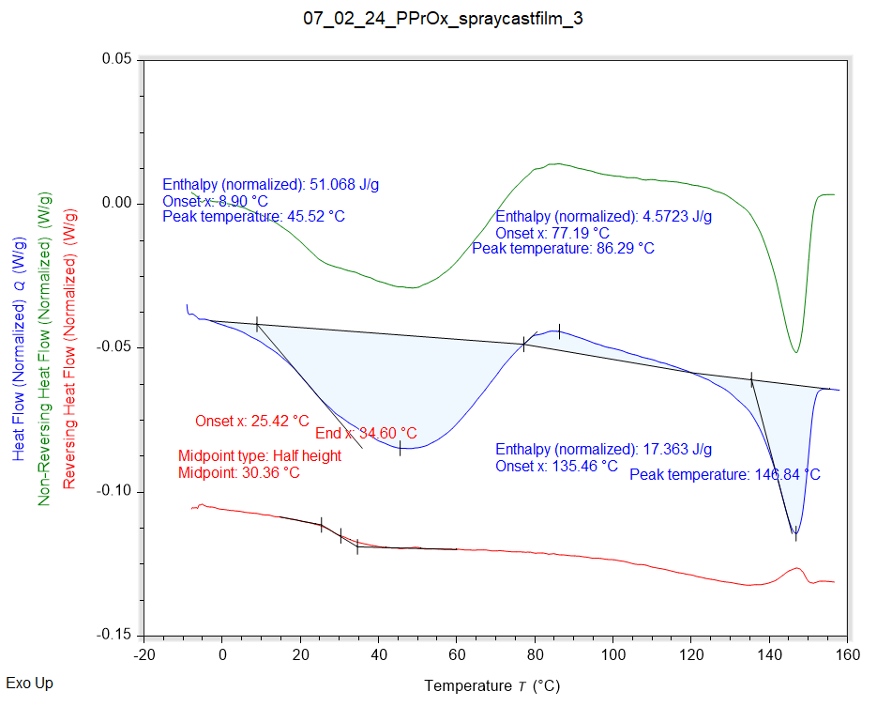

|  |  |
| --- | --- |
| Solvent HC1 | Peak Onset |
|  | 8.899 °C |

|  |  |  |  |
| --- | --- | --- | --- |
| Recrystallisation HC1 | Peak Onset | Peak Location | Peak Location |
|  | 77.188 °C | 86.294 °C | 86.294 °C |

|  |  |  |  |
| --- | --- | --- | --- |
| Melting HC1 | Peak Onset | Peak Location | Enthalpy |
|  | 135.459 °C | 146.841 °C | 17.363 J/g |

|  |  |
| --- | --- |
| Tg HC1 | Onset |
|  | 25.419 °C |

**HEATING CYCLE 2**

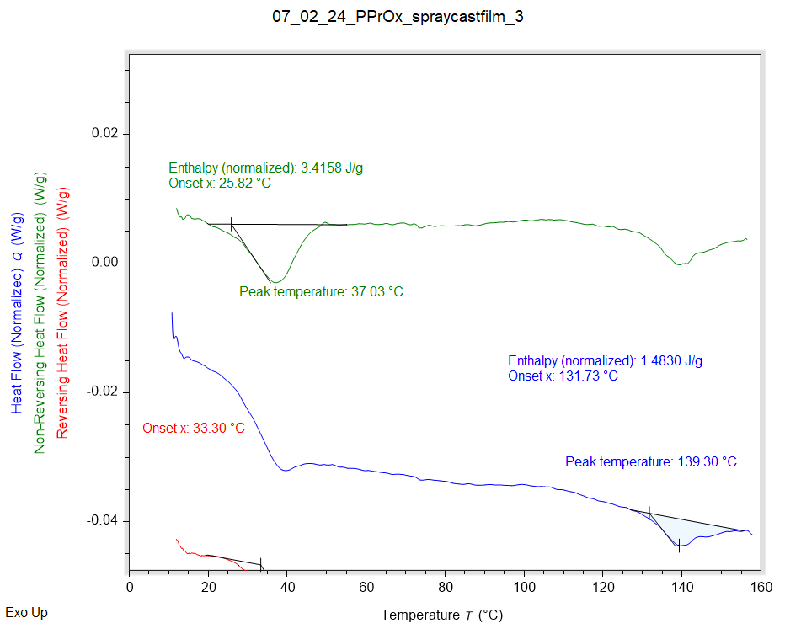

|  |  |  |  |  |  |
| --- | --- | --- | --- | --- | --- |
| Solvent HC1 | Peak Onset | Peak Location | Enthalpy | Extra 1 | Extra 2 |
|  | 25.821 °C | 37.027 °C | 3.4158 J/g | 3.4158 J/g | 3.4158 J/g |

|  |  |
| --- | --- |
| Melting HC1 | Enthalpy |
|  | 1.5785 J/g |

|  |  |  |
| --- | --- | --- |
| Tg HC1 | Onset | Midpoint |
|  | 33.303 °C | 39.561 °C |

**HEATING CYCLE 3**

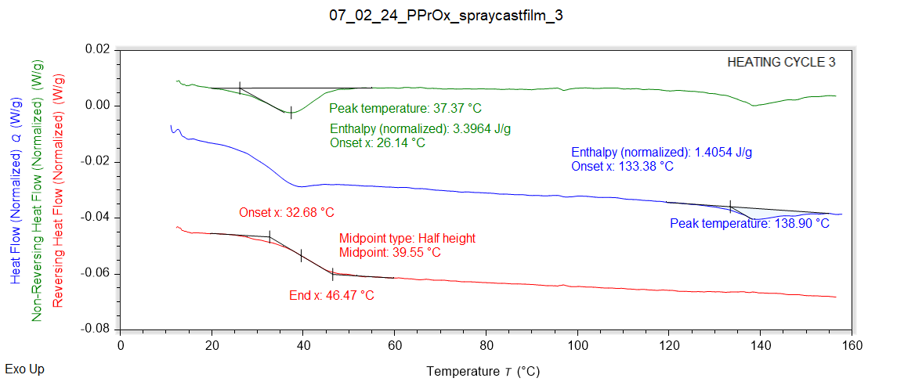

|  |  |  |  |  |
| --- | --- | --- | --- | --- |
| Solvent HC1 | Peak Onset | Peak Location | Enthalpy | Extra |
|  | 26.144 °C | 37.370 °C | 3.3964 J/g | 3.3964 J/g |

|  |  |
| --- | --- |
| Melting HC1 | Peak Onset |
|  | 133.385 °C |

|  |  |  |
| --- | --- | --- |
| Tg HC1 | Onset | Midpoint |
|  | 32.677 °C | 39.555 °C |